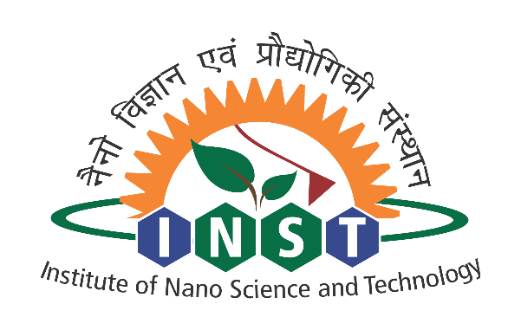
INSTITUTE OF NANO SCIENCE AND TECHN0LOGY
(An Autonomous Institute of Department of Science and Technology,
Government of India)
Knowledge City, Sector 81, SAS Nagar, Mohali- 140306, Punjab

FORM – 5 A
No: Mention the file no. DATE:
Walk-In Interview
Advertisement for engagement of Junior Research Fellow (JRF) under the ‘mentioned funding agency Name’ funded project at Institute of Nano Science and Technology
Highly motivated and bright candidates are invited for walk-in-Interview for engagement of Project Junior Research Fellow (JRF) in the research project funded by ‘mention the funding agency name’.
Date of walk in interview:
Reporting time and venue: 10.00 am at the above mentioned address.
Title of the Research Project: Title
Principal Investigator: Name and Designation of Scientist
Name of the position available: Junior Research Fellow
Number of positions available: One
Qualifications:
Essential Qualification: M.Sc./M.Tech. Degree in Chemistry/physics/Materials Science/ Nanoscience and Nanotechnology with NET/GATE qualification.
Desirable Experience: Experience in nanoscience and nanotechnology will be preferred.
Age limit: Must not be over 30 years as on mention the date of Walk-in-Interview, which is relaxable for certain reserved categories as per rules of Government of India.
Fellowship: Rs. 31,000/- (pm) + HRA (as applicable)
Project duration: Initially six months and may be extended based on performance of the candidate.
General Terms and Conditions:
- The position is purely temporary and on contractual basis. The position is co-terminus with the project. Candidate selected for this position can also apply for the regular PhD program of INST provided they satisfy eligibility criteria.
- No TA/DA will be paid for attending the interview.
- Original documents of age proof/certificates/degrees/mark sheets and other testimonials must be presented along with the self-attested photocopies of these documents at the time of interview.

Date of interview and Reporting Time:

For any query, candidates can contact on following address
​
Name and Designation of PI
Scientist-C
Institute of Nanoscience and Technology (INST),
Sector 81, Knowledge City, SAS Nagar- 140306, Punjab
E-mail: , Ph No.: +91-172-2297000 (Extn: )
Mobile:

